**Day 13**

// program using this keyword

class ReverseTest

{

int num;

int rem =0;

int rev =0;

ReverseTest()

{

this(123);

System.out.println("Default constructor invoked");

System.out.println("Reversed Number is "+rev);

}

ReverseTest(int num)

{

System.out.println("The number to be reversed "+num);

while(num!=0)

{

rem = num%10;

rev = rev*10+rem;

num = num/10;

}

}

}

class Test

{

public static void main(String args[])

{

ReverseTest obj = new ReverseTest();

}

}

**OUTPUT**

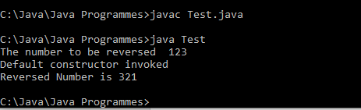

// Program to find the factorial of a number using this keyword.

class FactorialTest

{

int num;

FactorialTest()

{

this(5);

//System.out.println("Default Constructor invoked");

}

FactorialTest(int num)

{

int fact=1;

for(int i=1;i<=num;i++)

{

fact = fact*i;

}

System.out.println("Factorial of the number "+num+" is "+fact);

}

}

class Test1

{

public static void main(String args[])

{

FactorialTest obj = new FactorialTest();

}

}

**OUTPUT**

